2. Amazon EC2 (Elastic Compute Cloud):

**Overview:**

Amazon EC2 is a web service that provides resizable compute capacity in the cloud. It allows users to run virtual servers, known as instances, on-demand. EC2 instances are designed to handle various workloads and are commonly used for hosting applications, running batch processing, and more.

**Key Concepts:**

**1. Instances:**

- Definition:

An EC2 instance is a virtual server in the cloud that you can use to run applications. It provides compute capacity on-demand.

- Variety of Instance Types:

EC2 offers a broad selection of instance types optimized to fit different use cases. Examples include:

1. **Compute-Optimized Instances:**

Ideal for compute-bound applications that benefit from high-performance processors.

1. **Memory-Optimized Instances:**

Designed for memory-intensive applications, such as databases and analytics.

1. **GPU Instances:**

Equipped with Graphics Processing Units, suitable for tasks like machine learning and rendering.

**2. Security Groups:**

- Definition:

Security groups are virtual firewalls for your EC2 instances. They control inbound and outbound traffic by specifying rules.

- Inbound and Outbound Traffic Control:

Security groups operate at the instance level and manage traffic by allowing or denying communication based on rules. These rules include protocols, ports, and source/destination IP ranges.

- Stateful:

Security groups are stateful, meaning if you allow inbound traffic for a specific port, the corresponding outbound traffic is automatically allowed, and vice versa.

**3. Key Pairs:**

- Definition:

Key pairs are used to securely access EC2 instances. They consist of a public key, which is placed on the instance, and a private key, which is kept secure by the user.

- Secure Access:

When launching an EC2 instance, you specify the key pair to be associated with it. The private key is then used to authenticate and securely connect to the instance.

- SSH for Linux, RDP for Windows:

For Linux instances, SSH is commonly used, while Windows instances typically use Remote Desktop Protocol (RDP) for secure connections.

**Use Cases:**

- Web Hosting: EC2 instances are commonly used to host websites and web applications, providing scalable compute resources.

- Development and Testing: EC2 allows for the creation of development and testing environments with flexible and on-demand compute capacity.

- Big Data Processing: For running big data frameworks like Apache Hadoop and Apache Spark on scalable clusters using EC2 instances.

- High-Performance Computing (HPC): EC2 supports HPC applications that require significant computational power and parallel processing.

**Working with Amazon EC2:**

1. Launching Instances:

- Select an Amazon Machine Image (AMI) that serves as the template for your instance.

- Choose the instance type based on your application's requirements.

- Configure instance details, storage, and add tags.

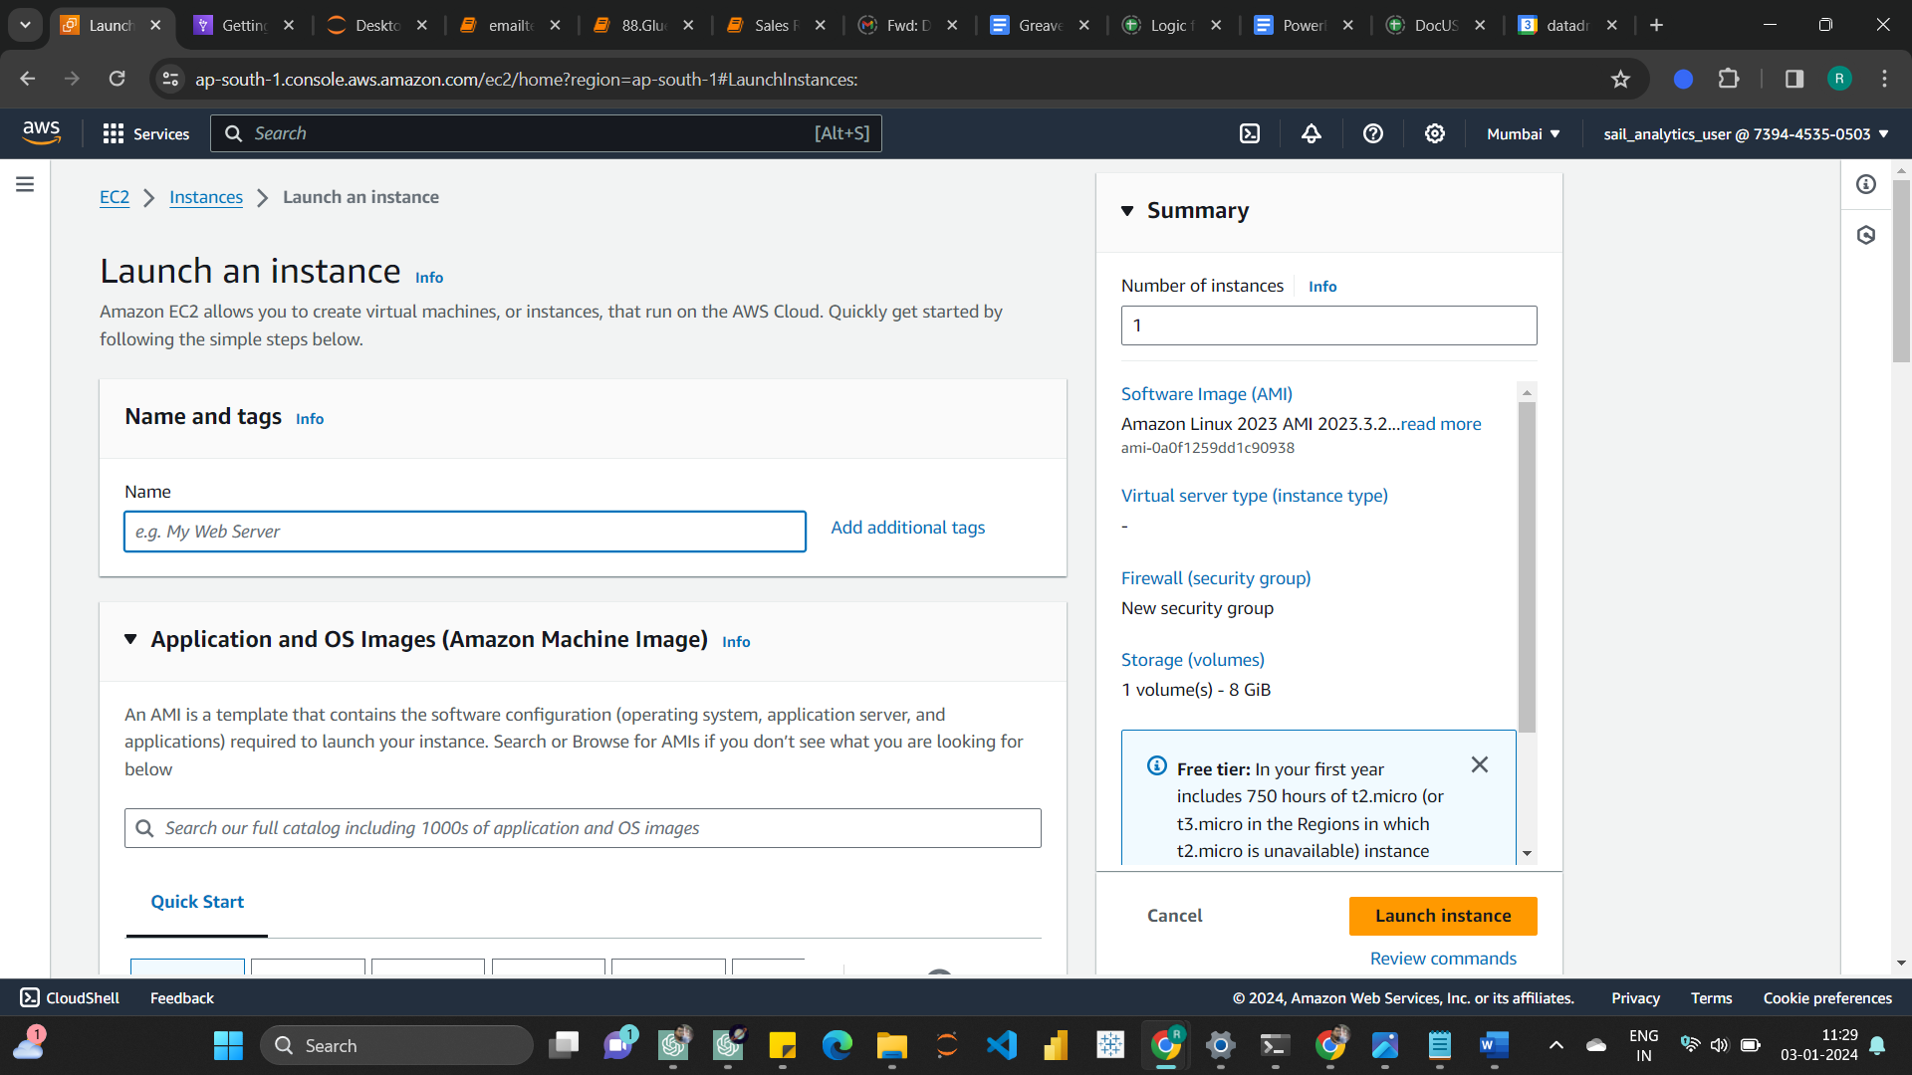

2. Security and Key Pair Configuration:

- Define security groups to control inbound and outbound traffic.

- Choose an existing key pair or create a new one for secure access.

3. Connecting to Instances:

- Use SSH (Secure Shell) for Linux instances or Remote Desktop Protocol (RDP) for Windows instances to connect.

- Use the private key associated with the key pair during the connection process.

4. Storage Options:

- EC2 instances come with attached storage known as Amazon Elastic Block Store (EBS).

- You can also use instance store volumes for temporary data.

5. Auto Scaling:

- Configure Auto Scaling groups to automatically adjust the number of instances based on demand.

**Best Practices:**

1. Instance Types:

- Choose an instance type that aligns with your application's requirements.

- Regularly assess your instance types to optimize for performance and cost.

2. Security Best Practices:

- Follow the principle of least privilege when configuring security groups.

- Regularly rotate and manage access keys for security.

3. Backups and Snapshots:

- Create regular backups of important data stored on EC2 instances.

- Use Amazon EBS snapshots for long-term storage.

4. Monitoring and Alerts:

- Set up Amazon CloudWatch for monitoring instance metrics.

- Create CloudWatch Alarms to receive notifications based on defined thresholds.

Next Steps:

Once you have a good grasp of Amazon EC2, consider exploring the following advanced topics:

- EC2 Spot Instances: Utilize spare EC2 capacity at a lower cost for fault-tolerant and flexible workloads.

- EC2 Reserved Instances: Commit to a one- or three-year term for discounted pricing compared to On-Demand instances.

- EC2 Instance Metadata and User Data: Learn about metadata and user data for customizing and configuring instances during launch.

Remember to practice your knowledge by creating and managing EC2 instances through the AWS Management Console, AWS CLI, or SDKs. If you have specific questions or need clarification on any topic, feel free to ask!